(Insert photo)

2023 Scholarship Application

Contact Information
Full Name: |  |  |  | Date:
 | Last | First | M.I.

Address:
 | Street Address | Apartment/Unit #

 | City | State | ZIP Code

Phone: |  | Email

Education
School Name: |  | Address:

 |  |  | Check one: | ☐ Freshman | ☐ Sophomore | ☐ Junior | ☐ Senior
 |  |  | Check one: | ☐ High School | ☐ University | ☐ Community College | ☐ Other

Anticipated Graduation Date |  |  | _________________________

2023 Scholarship Information

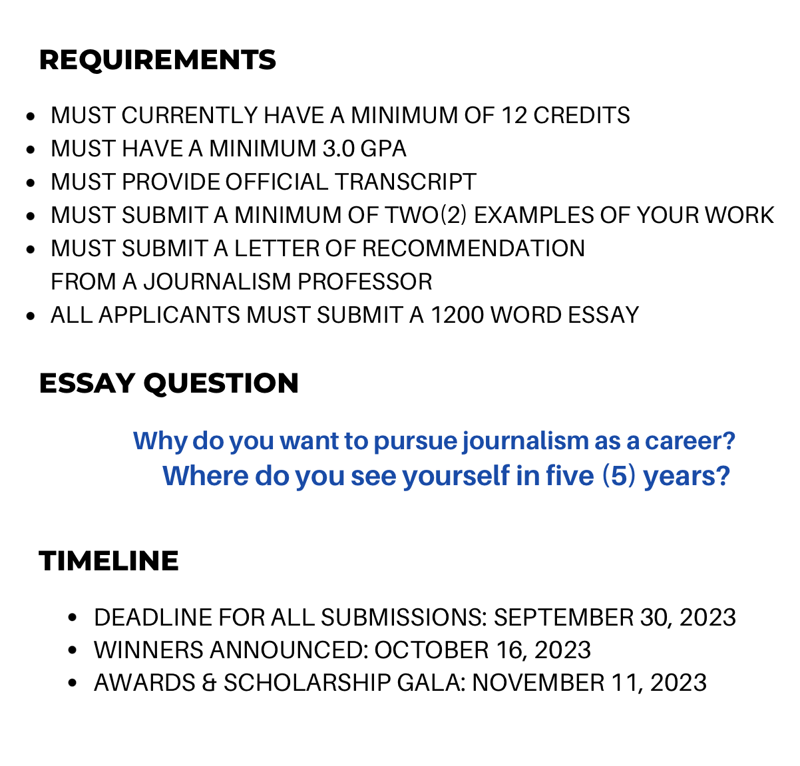
Scholarship winners must be present at the November
Awards & Scholarship Gala to receive their scholarship award

